Exercise 1: Configuring a Basic Spring Application
Pom.xml :
<project xmlns="http://maven.apache.org/POM/4.0.0"
xmlns:xsi="http://www.w3.org/2001/XMLSchema-instance"
xsi:schemaLocation="http://maven.apache.org/POM/4.0.0
http://maven.apache.org/xsd/maven-4.0.0.xsd">
<modelVersion>4.0.0</modelVersion>
<groupId>com.library</groupId>
<artifactId>LibraryManagement</artifactId>
<version>1.0-SNAPSHOT</version>

<dependencies>
<dependency>
<groupId>org.springframework</groupId>
<artifactId>spring-context</artifactId>
<version>5.3.34</version>
</dependency>
</dependencies>
</project>
BookService.java:
package com.library.service;

import com.library.repository.BookRepository;

public class BookService {
private BookRepository bookRepository;

// Setter for Spring DI
public void setBookRepository(BookRepository bookRepository) {
this.bookRepository = bookRepository;
}

public void addBook(String title) {
System.out.println("Service: Adding book - " + title);
bookRepository.saveBook(title);
}
}
BookRepository.java:
package com.library.repository;

public class BookRepository {
public void saveBook(String title) {
System.out.println("Repository: Book '" + title + "' saved to database.");
}
}
Main.java:
package com.library;

import com.library.service.BookService;
import org.springframework.context.ApplicationContext;
import org.springframework.context.support.ClassPathXmlApplicationContext;

public class MainApp {
public static void main(String[] args) {
ApplicationContext context = new ClassPathXmlApplicationContext("applicationContext.xml");

BookService bookService = (BookService) context.getBean("bookService");
bookService.addBook("Spring in Action");

((ClassPathXmlApplicationContext) context).close();
}
}

resources/applicationContext.xml
<?xml version="1.0" encoding="UTF-8"?>
<beans xmlns="http://www.springframework.org/schema/beans"
xmlns:xsi="http://www.w3.org/2001/XMLSchema-instance"
xsi:schemaLocation="
http://www.springframework.org/schema/beans
http://www.springframework.org/schema/beans/spring-beans.xsd">

<!-- Repository Bean -->
<bean id="bookRepository" class="com.library.repository.BookRepository" />

<!-- Service Bean with Dependency Injection -->
<bean id="bookService" class="com.library.service.BookService">
<property name="bookRepository" ref="bookRepository" />
</bean>
</beans>
Output :
Service: Adding book - Spring in Action
Repository: Book 'Spring in Action' saved to database.
Exercise 2: Implementing Dependency Injection
resources/applicationContext.xml
<?xml version="1.0" encoding="UTF-8"?>
<beans xmlns="http://www.springframework.org/schema/beans"
xmlns:xsi="http://www.w3.org/2001/XMLSchema-instance"
xsi:schemaLocation="
http://www.springframework.org/schema/beans
http://www.springframework.org/schema/beans/spring-beans.xsd">
<bean id="bookRepository" class="org.library.repository.BookRepository"/>
<bean id="bookService" class="org.library.service.BookService">
<property name="bookRepository" ref="bookRepository"/>
</bean>
</beans>

BookRepository.java
package org.library.repository;

public class BookRepository {
public void saveBook(String title) {
System.out.println("Repository Info: Book '" + title + "' successfully saved in the database.");
}
}

BookService.java
package org.library.service;

import org.library.repository.BookRepository;

public class BookService {
private BookRepository bookRepository;

public void setBookRepository(BookRepository bookRepository) {
this.bookRepository = bookRepository;
}

public void addBook(String title) {
System.out.println("Service Alert: Initiating save process for the new book entry.");
bookRepository.saveBook(title);
}
}

Main.java
package org.library;

import org.library.service.BookService;
import org.springframework.context.ApplicationContext;
import org.springframework.context.support.ClassPathXmlApplicationContext;

public class Main {
public static void main(String[] args) {
ApplicationContext context = new ClassPathXmlApplicationContext("applicationContext.xml");
BookService bookService = (BookService) context.getBean("bookService");

bookService.addBook("Effective Java");
}
}

Output :
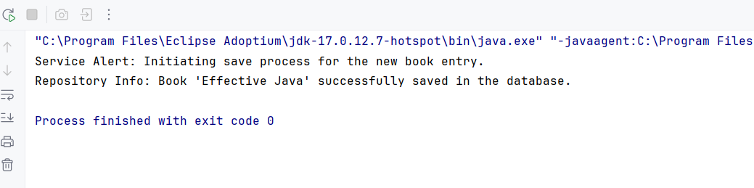
Exercise 4: Creating and Configuring a Maven Project
pom.xml
<project xmlns="http://maven.apache.org/POM/4.0.0"
xmlns:xsi="http://www.w3.org/2001/XMLSchema-instance"
xsi:schemaLocation="http://maven.apache.org/POM/4.0.0
http://maven.apache.org/xsd/maven-4.0.0.xsd">
<modelVersion>4.0.0</modelVersion>

<groupId>com.library</groupId>
<artifactId>LibraryManagement</artifactId>
<version>1.0-SNAPSHOT</version>

<properties>
<java.version>1.8</java.version>
<spring.version>5.3.34</spring.version>
<servlet.version>4.0.1</servlet.version>
</properties>

<dependencies>
<dependency>
<groupId>org.springframework</groupId>
<artifactId>spring-context</artifactId>
<version>${spring.version}</version>
</dependency>
<dependency>
<groupId>org.springframework</groupId>
<artifactId>spring-aop</artifactId>
<version>${spring.version}</version>
</dependency>
<dependency>
<groupId>org.springframework</groupId>
<artifactId>spring-webmvc</artifactId>
<version>${spring.version}</version>
</dependency>
<dependency>
<groupId>javax.servlet</groupId>
<artifactId>javax.servlet-api</artifactId>
<version>${servlet.version}</version>
<scope>provided</scope>
</dependency>
</dependencies>

<build>
<pluginManagement>
<plugins>
<plugin>
<groupId>org.apache.maven.plugins</groupId>
<artifactId>maven-compiler-plugin</artifactId>
<version>3.10.1</version>
<configuration>
<source>${java.version}</source>
<target>${java.version}</target>
</configuration>
</plugin>
</plugins>
</pluginManagement>
</build>
</project>
Exercise 5: Configuring the Spring IoC Container
applicationContext.xml
<?xml version="1.0" encoding="UTF-8"?>
<beans xmlns="http://www.springframework.org/schema/beans"
xmlns:xsi="http://www.w3.org/2001/XMLSchema-instance"
xsi:schemaLocation="
http://www.springframework.org/schema/beans
http://www.springframework.org/schema/beans/spring-beans.xsd">
<bean id="bookRepository" class="org.library.repository.BookRepository"/>
<bean id="bookService" class="org.library.service.BookService">
<property name="bookRepository" ref="bookRepository"/>
</bean>
</beans>

BookRepository.java
package org.library.repository;

public class BookRepository {
public void saveBook(String title) {
System.out.println("Repository Log: Book '" + title + "' has been recorded successfully.");
}
}

BookService.java
package org.library.service;

import org.library.repository.BookRepository;

public class BookService {
private BookRepository bookRepository;

public void setBookRepository(BookRepository bookRepository) {
this.bookRepository = bookRepository;
}

public void addBook(String title) {
System.out.println("Service Notice: Processing request to add a book...");
bookRepository.saveBook(title);
}
}

Main.java
package org.library;

import org.library.service.BookService;
import org.springframework.context.ApplicationContext;
import org.springframework.context.support.ClassPathXmlApplicationContext;

public class Main {
public static void main(String[] args) {
ApplicationContext context = new ClassPathXmlApplicationContext("applicationContext.xml");

BookService bookService = (BookService) context.getBean("bookService");
bookService.addBook("Clean Code");
}
}
Output :
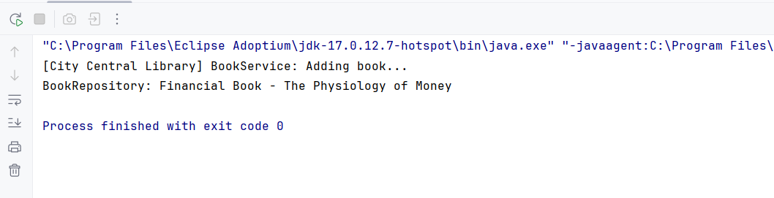
Exercise 7: Implementing Constructor and Setter Injection
resources/applicationContext.xml
<?xml version="1.0" encoding="UTF-8"?>
<beans xmlns="http://www.springframework.org/schema/beans"
xmlns:xsi="http://www.w3.org/2001/XMLSchema-instance"
xsi:schemaLocation="http://www.springframework.org/schema/beans
http://www.springframework.org/schema/beans/spring-beans.xsd">

<bean id="bookRepository" class="org.library.repository.BookRepository"/>
<bean id="bookService" class="org.library.service.BookService">
<constructor-arg ref="bookRepository"/>
<property name="libraryName" value="Central Knowledge Hub"/>
</bean>

</beans>

BookService.java
package org.library.service;

import org.library.repository.BookRepository;

public class BookService {
private BookRepository repo;
private String libraryName;

public BookService(BookRepository repo) {
this.repo = repo;
}

public void setLibraryName(String libraryName) {
this.libraryName = libraryName;
}

public void registerBook(String bookTitle) {
System.out.println("Library [" + libraryName + "] is registering a new book...");
repo.saveBook(bookTitle);
}
}

BookRepository.java
package org.library.repository;

public class BookRepository {
public void saveBook(String title) {
System.out.println("BookRepository: Financial Book - " + title);
}
}

Main.java
package org.library;

import org.library.service.BookService;
import org.springframework.context.ApplicationContext;
import org.springframework.context.support.ClassPathXmlApplicationContext;

public class Main {
public static void main(String[] args) {
ApplicationContext context = new ClassPathXmlApplicationContext("applicationContext.xml");

BookService service = (BookService) context.getBean("bookService");
service.registerBook("The Physiology of Money");
}
}
Output :
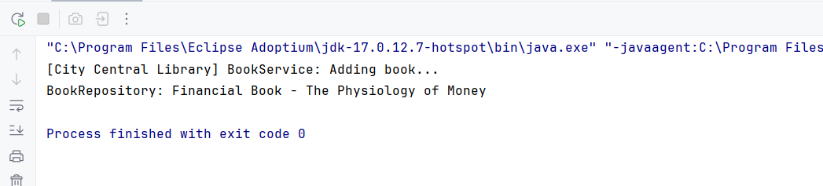
Exercise 9: Creating a Spring Boot Application
BookController.java:
package com.example.library.controller;
import com.example.library.entity.Book;
import com.example.library.repository.BookRepository;
import org.springframework.beans.factory.annotation.Autowired;
import org.springframework.web.bind.annotation.*;
import java.util.List;
import java.util.Optional;
@RestController
@RequestMapping("/api/books")
public class BookController {
@Autowired
private BookRepository bookRepository;
@GetMapping
public List<Book> getAllBooks() {
return bookRepository.findAll();
}
@GetMapping("/{id}")
public Optional<Book> getBookById(@PathVariable Long id) {
return bookRepository.findById(id);
}
@PostMapping
public Book addBook(@RequestBody Book book) {
return bookRepository.save(book);
}
@PutMapping("/{id}")
public Book updateBook(@PathVariable Long id, @RequestBody Book bookDetails) {
Book book = bookRepository.findById(id).orElseThrow();
book.setTitle(bookDetails.getTitle());
book.setAuthor(bookDetails.getAuthor());
book.setCategory(bookDetails.getCategory());
return bookRepository.save(book);
}
@DeleteMapping("/{id}")
public void deleteBook(@PathVariable Long id) {
bookRepository.deleteById(id);
}
}

Book.java:
package com.example.library.entity;
import jakarta.persistence.*;
@Entity
public class Book {
@Id
@GeneratedValue(strategy = GenerationType.IDENTITY)
private Long id;
private String title;
private String author;
private String category;
public Book() {}
public Book(String title, String author, String category) {
this.title = title;
this.author = author;
this.category = category;
}
// Getters and setters
public Long getId() {
return id;
}
public String getTitle() {
return title;
}
public void setTitle(String title) {
this.title = title;
}
public String getAuthor() {
return author;
}
public void setAuthor(String author) {
this.author = author;
}
public String getCategory() {
return category;
}
public void setCategory(String category) {
this.category = category;
}
}

LibraryManagementApplication.java:
package com.example.library;
import org.springframework.boot.SpringApplication;
import org.springframework.boot.autoconfigure.SpringBootApplication;
@SpringBootApplication
public class LibraryManagementApplication {
public static void main(String[] args) {
SpringApplication.run(LibraryManagementApplication.class, args);
}
}
Application.properties:

# H2 In-memory Database
spring.datasource.url=jdbc:h2:mem:librarydb
spring.datasource.driverClassName=org.h2.Driver
spring.datasource.username=sa
spring.datasource.password=
spring.jpa.database-platform=org.hibernate.dialect.H2Dialect
# Enable H2 Console
spring.h2.console.enabled=true
spring.h2.console.path=/h2-console
# Show SQL
spring.jpa.show-sql=true
spring.jpa.hibernate.ddl-auto=update

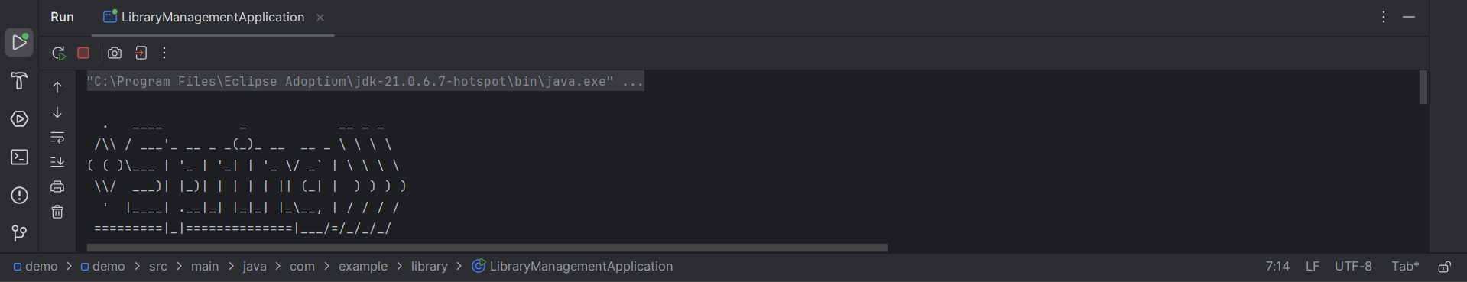

Ex 1 : Spring Data JPA – Quick Example
Product.java
import jakarta.persistence.Entity;
import jakarta.persistence.GeneratedValue;
import jakarta.persistence.Id;

@Entity
public class Product {
@Id
@GeneratedValue
private Long id;
private String name;
private String category;

public Long getId() { return id; }
public void setId(Long id) { this.id = id; }

public String getName() { return name; }
public void setName(String name) { this.name = name; }

public String getCategory() { return category; }
public void setCategory(String category) { this.category = category; }
}
ProductRepository.java
import org.springframework.data.jpa.repository.JpaRepository;
import java.util.List;

public interface ProductRepository extends JpaRepository<Product, Long> {
List<Product> findByCategory(String category);
}

ProductService.java
import org.springframework.beans.factory.annotation.Autowired;
import org.springframework.stereotype.Service;
import java.util.List;

@Service
public class ProductService {

@Autowired
private ProductRepository repo;

public void saveProduct() {
Product product = new Product();
product.setName("Laptop");
product.setCategory("Electronics");
repo.save(product);
}

public List<Product> getElectronics() {
return repo.findByCategory("Electronics");
}
}
Ex 4 : Difference between JPA, Hibernate and Spring Data JPA
Aspect | JPA (Java Persistence API) | Hibernate | Spring Data JPA
Type | Specification (interface) | Implementation (framework) | Abstraction layer on top of JPA
Created By | Java EE / Jakarta EE | Red Hat | Spring Team (Pivotal)
Purpose | Standard API for ORM in Java | ORM framework implementing JPA | Simplifies JPA by removing boilerplate
Implements | Only the interfaces and annotations | Full JPA + extra features like caching, lazy loading | Uses JPA (usually Hibernate) + Spring features
Examples | @Entity, @Id, EntityManager | Session, Transaction, Criteria, HQL | CrudRepository, JpaRepository, @Repository
Config File | persistence.xml | hibernate.cfg.xml | application.properties or application.yml in Spring Boot
Boilerplate Code | High – manual transaction handling, persistence context | Medium – simplified but still manual | Low – auto-wired repositories, no need for boilerplate
Query Language | JPQL (Java Persistence Query Language) | JPQL + HQL (Hibernate Query Language) | JPQL + Query derivation from method names
Transactions | Manual via EntityManager | Manual via Session and Transaction | Handled automatically with @Transactional
Lazy/Eager Fetching | Supported | Advanced support with better control | Inherited from JPA/Hibernate
Caching | Basic support | Built-in support (1st and 2nd level cache) | Delegated to Hibernate (depends on provider)
Pagination/Sorting | Manual | Manual | Built-in with Pageable, Sort interfaces
Repository Layer | Must be manually implemented | Optional helper classes | Interface-based (JpaRepository, CrudRepository, etc.)
Learning Curve | Steep – needs deep understanding of JPA | Moderate – still low-level API | Easy – ideal for beginners and rapid development
Best Use Case | If you want pure Java EE application or need full control | When you want advanced ORM features with flexibility | If you're using Spring Boot or want fast, clean development
Customization | Full flexibility | Full flexibility + extra features | High-level abstraction (but can customize with custom repos)
Vendor Independence | Yes – provider-neutral (choose Hibernate, EclipseLink, etc.) | No – Hibernate specific | Uses JPA, usually with Hibernate under the hood
Unit Testing | Needs mocking EntityManager | SessionFactory setup required | Easy with @DataJpaTest
Performance Tuning | Needs manual optimization | Better optimization features | Relies on underlying JPA provider (often Hibernate)
Community Support | Good | Excellent – widely used ORM framework | Excellent – widely used in Spring ecosystem
Popular With | Java EE projects, enterprise systems | Hibernate-focused apps, legacy systems | Spring Boot and microservice-based applications
Additional Features | None (just the API) | Caching, Dirty Checking, Native SQL Support | Auto Query Methods, Pagination, Specification, Query by Example

